Use case 5 issues

1. Use case 5 (User_Genre.py)

This code fetches data for already given date and page number.

1. Use case 5(genre2.py)

This code fetches data from API for user entered date and all pages but it says movie details dictionary does not have key “genres” in first loop

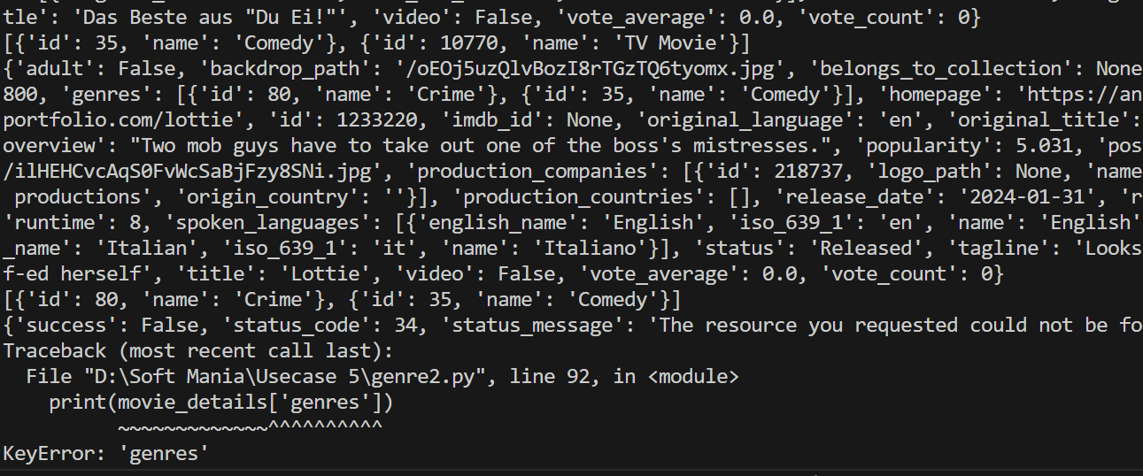

1. Use case 5 (Genre_new.py)

This code fetches data from API for user entered date and all pages but it gave session time out error